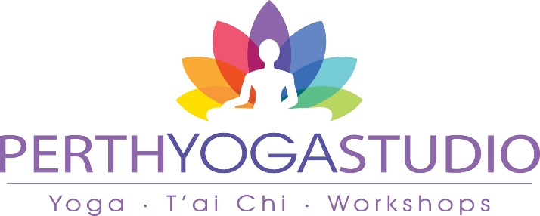
6-7 Rose Terrace, Perth PH1 5HA
ASTROLOGY
with the wonderful TONY YOUNG Saturday, 25 May 2024, 2 – 5pm
Birth Chart Astrology is a science to help us know ourselves better – completely different from the usual Sun Sign astrology. In this workshop, Tony will prepare your chart with prior info, as below on booking form, and then give an analysis to explain what it means.
Astrology is so much more than your star sign - the zodiac sign the sun was in when you were born is just one detail in your larger, personal astrological story.

Tony will be sharing a very special Introductory Workshop on Astrology. This three-hour workshop will introduce you to the basics of reading your own birth chart. You’ll learn about the various celestial bodies in our solar system and how they might offer you insight into different aspects of your personality and life.

Your birth chart is informed by month, year, time and birthplace - you can think of it as a snapshot of the sky when you were born - and you’ll receive your own chart as part of this workshop. www.namaha.co.uk

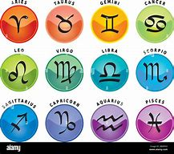
BOOKING FORM Cost: £48 to include your birth chart prepared in advance
Name ………………………………………………………………….
Contact: Phone or email…………………………………………………………………….
Date, time and place for your Astrology Birth Chart –
DATE:…………………TIME:………………PLACE: ……………………………………
Forms can be returned online to June Mitchell at june.cysyoga@gmail.com with bank transfer to: Perth Yoga Studio; 83 47 00; 11500664. Or leave form with your teacher with cash.
Enquiries to June on 07734 695 273 www.perthyogastudio.com

